Making a Prompt to Lay on a Dashboard
Purpose: to make a re-useable prompt that will lay on top of reports or dashboards in Analytics.
Solution:
In Analytics, go to new:
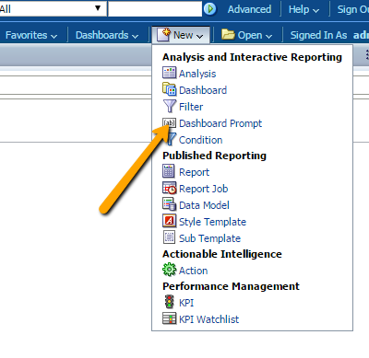
Figure 1: You need to create a dashboard prompt.
Pick the Subject Area your criteria will come from.
I chose Users for this particular example.
The prompt should be used for fields that are used over and over again, and that people will want to make their own choices from.
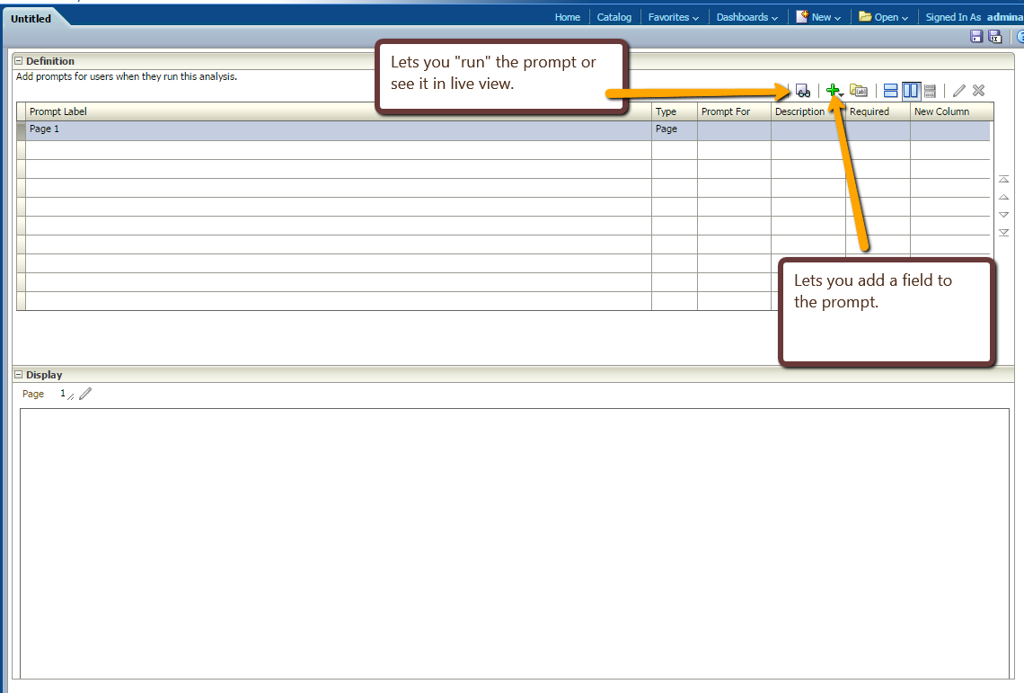
Figure 2: the design screen
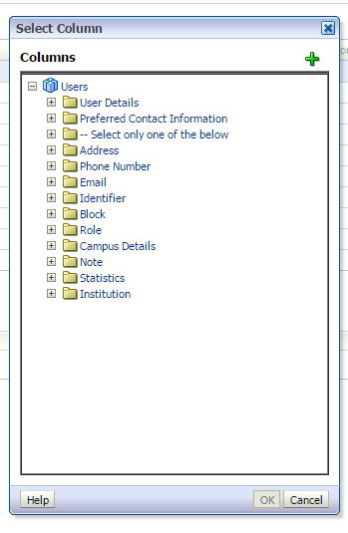
To begin adding fields, use the green Plus Sign.
From the choices given, you will want to select “Column Prompt”
Just like in any regular analytics report, select the column that you want to allow others to filter on. For mine, I’m going to choose from Role, and choose Role Type. You then get to decide some filtering options.
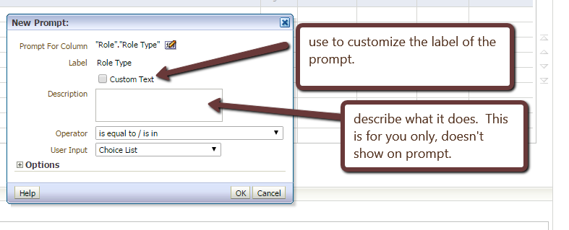
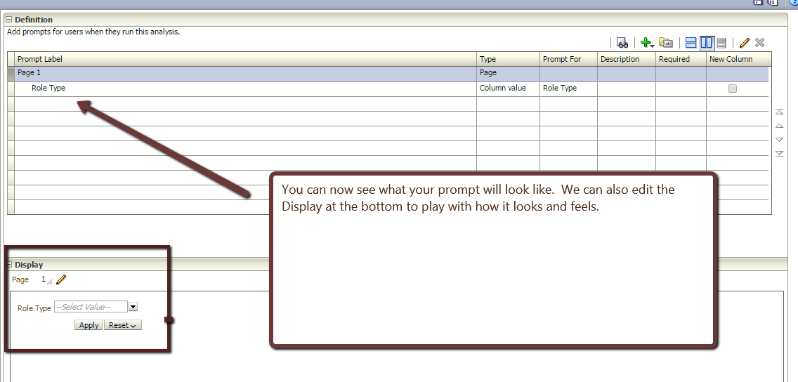

If you want a second filter added to your prompt, add in the same way. Now we need to save our prompt.
This is where a trick comes in.
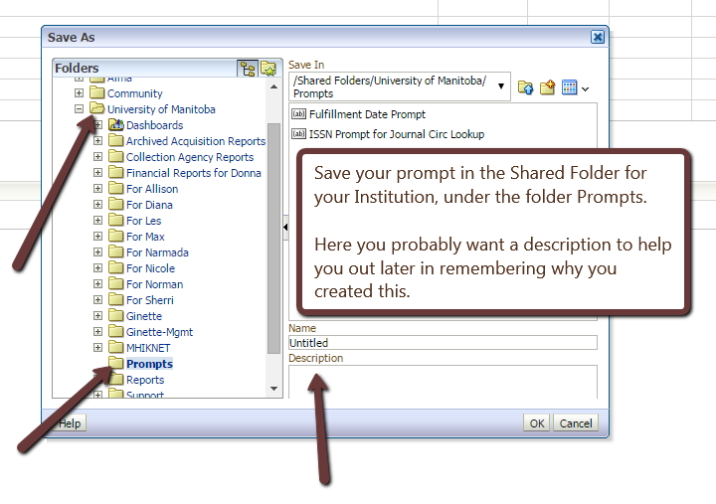
Use Save As:

Now that we’ve saved, we can tweak the Display a bit.
Use the Pencil to open up the options:
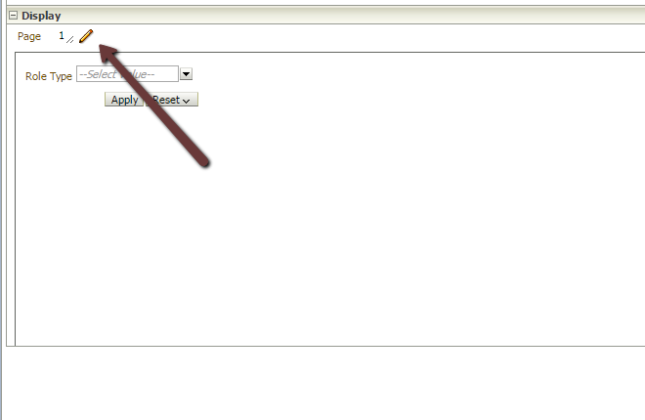
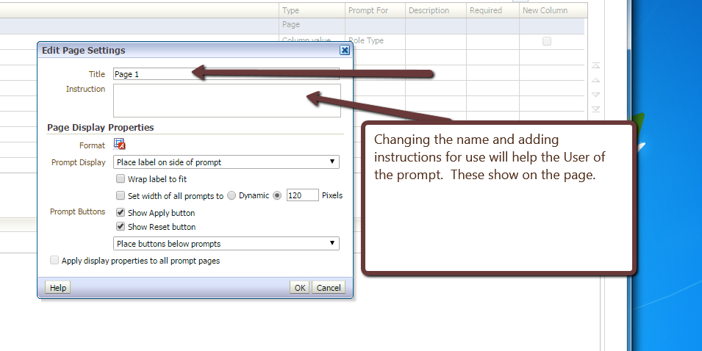
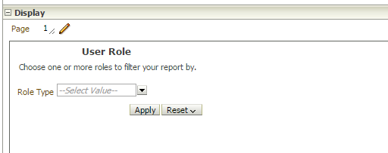
Note the instruction and title of the prompt changed
Ensure that you saved all your changes. Now the prompt is ready to be applied; however, we must first make our report ready for the prompt!.

The Report

Editing the report to accept the prompt
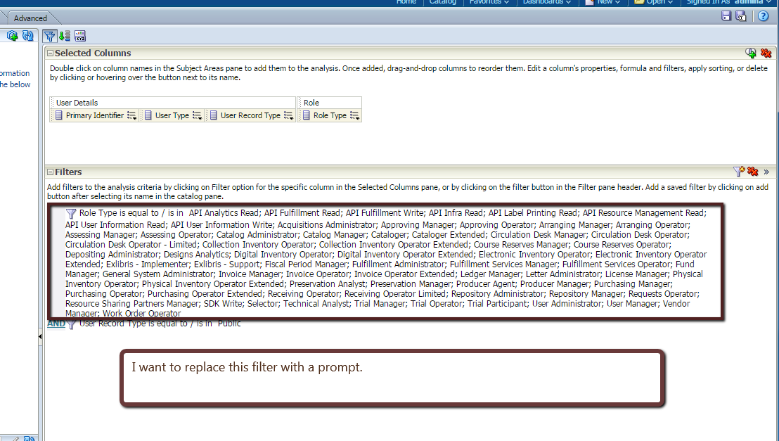
I no longer want to have this ugly filter in my report. I want to make this report widely available and want the user of it to choose the filter on the fly.
First, I need to delete the filter. Use the X while hovering over the filter to remove it.
Next, we need to add the fact that we will prompt for a filter.
The column in our filter should be the same as the column on our prompt. On the column we wish to filter, go to the filter:
then from the Operator, choose “Is Prompted”

Save the report in the Shared Folders for your Institution.

Applying the Prompt to a Dashboard

First you need to have a dashboard created. The dashboard should be saved under your Institutions Shared Folder, in the Dashboard Folder.

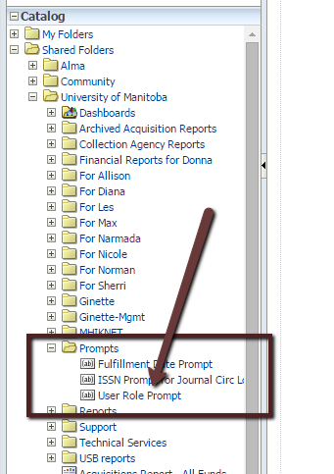
To create a Dashboard:
Go to New, choose Dashboard.
From the Catalogue box on the bottom left, choose the Prompt you just created from the Prompts folder under your Institution’s shared folder.
You can now drag and drop this prompt onto the dashboard.
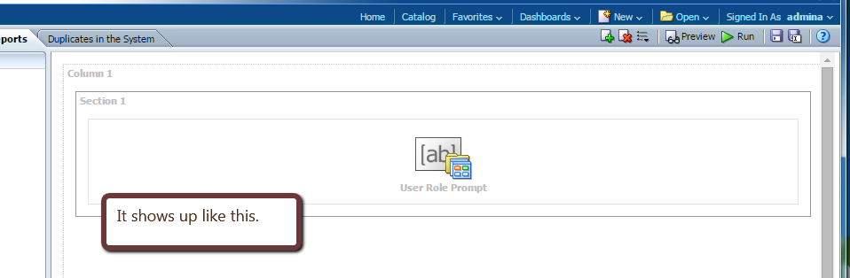

Now you need the report you just created to put on the dashboard. Open the folder from the catalogue box and drag it over to the dashboard.
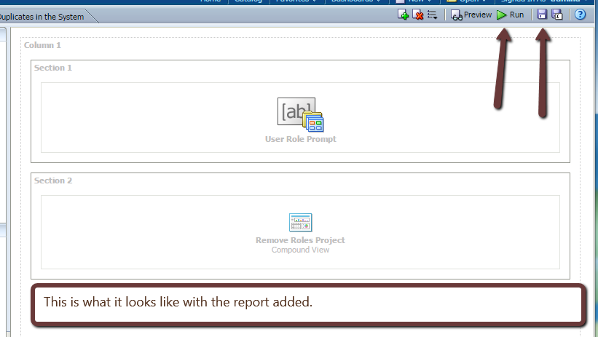

Make sure to save the report, then you can Preview it or Run it.
When I run my Dashboard:
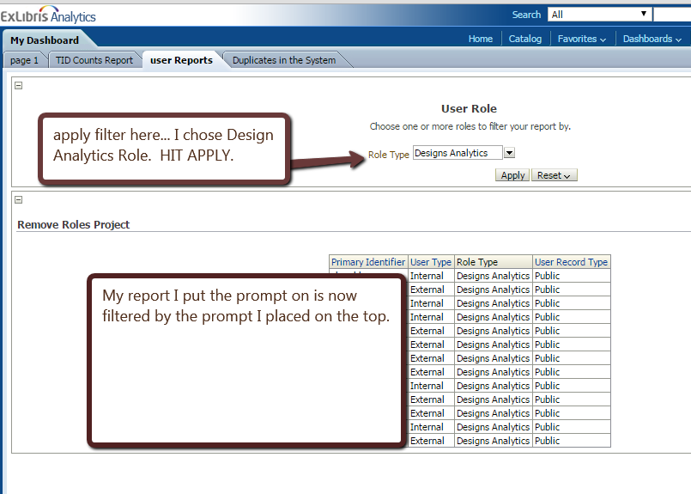

Editing the dashboard
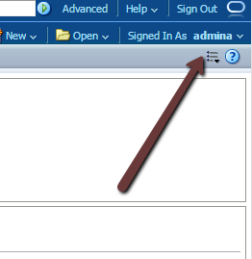
If you need to go back and make tweaks to the dashboard, just use the options button at the top of the screen:

Choose Edit Dashboard to open it up. You can even use the same option in the Dashboard and edit the reports right from the edit dashboard screen!

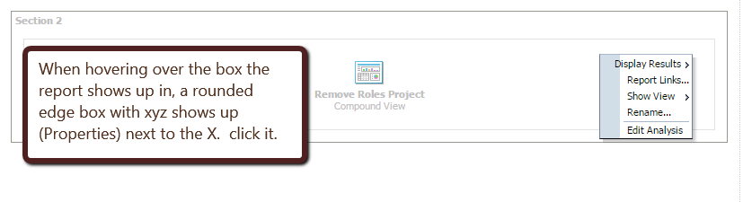
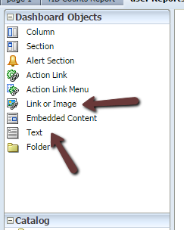
Feel free to play with the other links under “Dashboard Objects” to add text, hyper links out to the web, etc.

